**IT24100270**

**Jathusha.S**

**SLIIT – Malabe**

**Probability and statistics – IT2120**

**Labsheet 09**

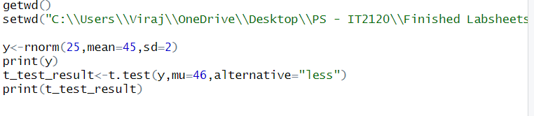

**output**



